HR QUESTIONS

Question] Tell me about yourself.

->I'm Rutuja Tathe, and I currently live in Pune. I work at Neutrino Tech Systems as an Associate Software Engineer with 1.9 years of experience. During this time I've worked with Angular, HTML, CSS, Java, Spring Boot, SQL, and TypeScript, as well as libraries like Angular Material and Bootstrap. My work includes creating responsive web applications, integrating RESTful APIs, and making sure they work well on all browsers. I literally enjoy building user-friendly and scalable applications that provide a smooth experience.

Project Information:

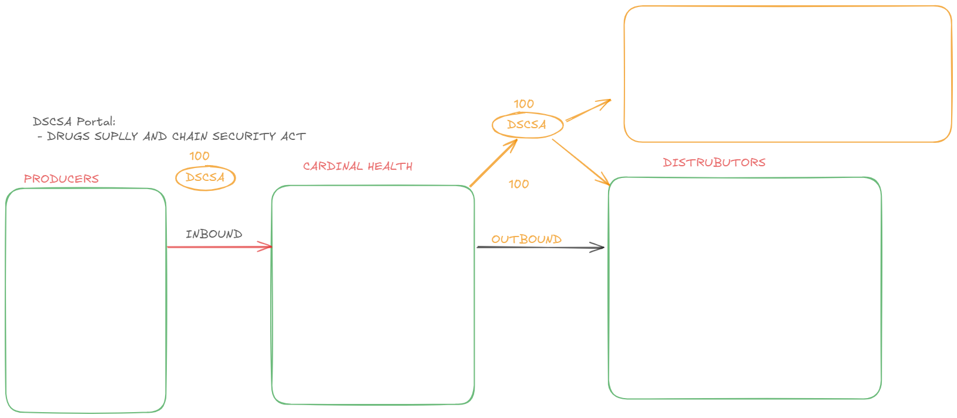
1.DSCSA portal ?

-The DSCSA portal was developed for U.S. residents as part of the Drug Supply Chain And Security Act (DSCSA). The portal manages both inbound and outbound rules for tracking drug supplies.
- Inbound Rules: When producers send data to their clients.
- Outbound Rules: When clients send data to distributors.
The DSCSA portal functions like an Excel sheet, where columns and rows are validated based on specific criteria using Angular Material. It ensures the supply data matches the distributor's data (e.g., tablet count) before the shipment reaches the distributor. If the data matches, it's marked as correct; If their is some mismatched in data then error occur.
I implemented this functionality for both inbound and outbound rules.

2.Alumini Portal?
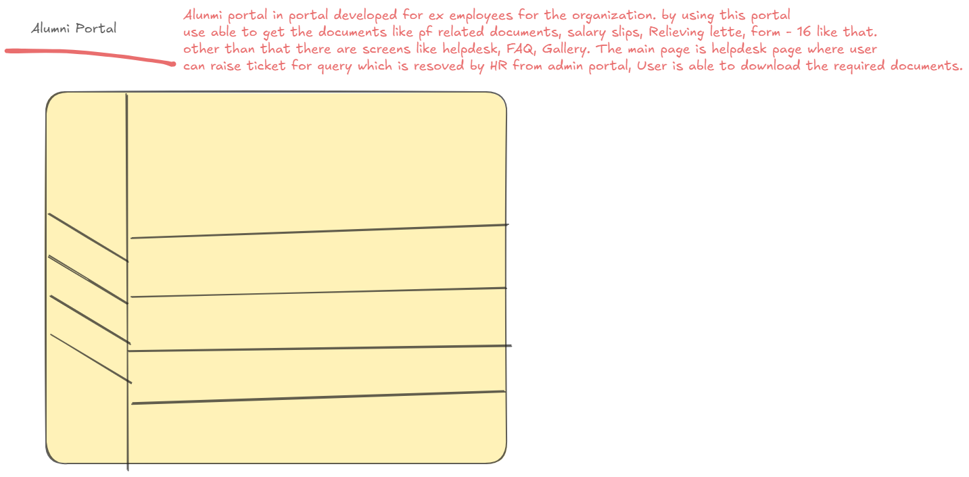
Alumini portal in portal developed for ex employees for the organization. by using this portal
user able to get the documents like pf related documents, salary slips, Relieving letter, form - 16 like that.
other than that there are others screens like helpdesk , FAQ, Gallery. The main page is helpdesk page where user
can raise ticket for query which is resoved by HR from admin portal, User is able to download the required documents. The employee related data stored in database using MangoDb. and the required document store in Amazon S3 bucket

Question] Are you ready to join immediately ? notice period?

-> My company has official 15 days notice period and ,but I can join immediately as my current project is almost complete with no dependencies on me. The project will finish in a few days, and I will be released early . [I initiate resignation once i received the offer letter] , I have already discussed this with my manager.

What is your notice period?
-My official notice period is 15 days but depending on how the interviews goes i can resigned and request early release if required.

A couple of colleagues are recently released and they are able to secure early release and i do have accumulated leaves and disposal so I’m pretty confident about join within 15 days.

Or
My official notice period is 15 days but depending on how the interview goes i can resigned and request early release if required. Couple of colleagues are recently released and they are able to secure early release so I’m pretty confident about join within 15 days.

But what you can’t join early?
- I’m confident that i can join early, i might not join early if my team genuinely needs me and then in that case I wrap things responsibly and then onboard with you to start on the note and I’m sure you’d expect the same level of commitment if i were working in your company

Why are you looking for a change?

-> I have been working in current organization around 1,9 years, I have learned a lot, and I have greatly improved my skills set. However, I feel that I need to change this job to really advance in my career. I believe such a change can result in something good, and it is sometimes necessary if you want to get to the next step of your career.

Do you have any question?
-Can you share me how the company celebrate and rewards employee success and great performance?
-

what is your salary?
-I am currently drawing 5lpa and I’ve done my research and roles with my expertise on this technology and from my experience they currently offering between 7 to 8 lakh .Does this range fit well in your budget?

What are you salary expectations?
-Honestly this is very important career switch for me and my main priority is to right into roles with great leaders, amazing projects and positive work culture. where i can stay associated for a good four to five year so for now i am comfortable with standard industry hike.

Question] Are you ready to relocate?
->I’m open to relocating for the role and ready to move as needed. I’m excited about the opportunity to join your organization and flexible with the relocation process.

About your day to day activities?

- We manage day to day activity using jira.

What are your key strengths as an Angular Developer?

-> Sample Answer :My greatest strength is my ability to stay organized and manage multiple task at once.I have ability to break complex project into smaller task and finding efficient solution to complete them.

4. What challenges have you faced in your Angular projects, and how did you overcome them?

->One challenge I faced was improving the performance of a large Angular application with slow loading times. I fixed this by using lazy loading for modules, applying OnPush change detection, and reducing the size of bundled files. These changes made the app load much faster and improved the user experience

5. How do you stay updated with the latest Angular trends and features?

-> I keep up with Angular by reading blogs, documentation, and forums like Angular Dev Community and Stack Overflow. I also take online courses, join webinars, and try out new features by building small projects.

6. How do you prioritize tasks and handle deadlines in your projects?

-> I prioritize tasks by breaking down project requirements into smaller steps. I use tools like Jira or Trello to track progress and stay on schedule. When facing tight deadlines, I focus on the most important features first and keep clear communication with the team to stay aligned.

7. What has been your most significant achievement as an Angular Developer?

-> Sample Answer:
"My most significant achievement was leading the development of a web application that improved user engagement by 40%. I implemented key features, optimized performance, and ensured seamless integration with the backend, which resulted in excellent client feedback."

8. Can you work well both independently and in a team?

-> Sample Answer:
"Yes, I can work efficiently both independently and as part of a team. I enjoy collaborating with others to solve problems and build innovative solutions, but I am also comfortable taking ownership of tasks and ensuring they are completed successfully."

9. What motivates you as a developer?

-> Sample Answer:
"I am motivated by the opportunity to solve complex problems, build user-friendly applications, and see the impact of my work in improving user experiences. Continuous learning and staying updated with the latest technologies also drive my passion for development."

10. Why should we hire you?

-> Sample Answer:
"I bring 2 years of hands-on experience in Angular development, strong problem-solving skills, and a proven ability to deliver high-quality web applications. I am dedicated to continuous learning and contributing to the success of the team by implementing efficient and scalable solutions."

11. How do you handle conflict or disagreement in a team?

-> Sample Answer:
"When faced with conflict, I prioritize understanding the perspectives of all parties involved. I communicate openly, focus on the project goals, and work collaboratively to find a solution that benefits the team. Maintaining professionalism and respect is always my approach."

12. Where do you see yourself in 5 years?

-> Sample Answer:
"In 5 years, I see myself as a senior Angular Developer or team lead, mentoring junior developers and contributing to large-scale, impactful projects. I also aim to deepen my expertise in Angular and explore related technologies like React or Vue.js."

13. What steps do you take to ensure code quality in your Angular projects?

-> Sample Answer:
"I ensure code quality by following best practices such as using Angular's CLI tools, adhering to the Angular style guide, writing unit tests, and conducting thorough code reviews. I also maintain proper documentation and regularly refactor code to improve readability and maintainability."

14. Do you have any experience with Angular performance optimization?

-> Sample Answer:
"Yes, I have optimized performance in Angular applications by implementing lazy loading, using Ahead-of-Time (AOT) compilation, and employing OnPush change detection strategies. I also reduce unnecessary API calls and bundle sizes by using tools like Webpack and Angular CLI."

15. Do you have any questions for us?

-> Sample Answer:
"Yes, I’d like to know more about the tools and technologies your team is currently using. Additionally, could you share insights about the growth opportunities in this role and the key challenges you are currently facing?"

